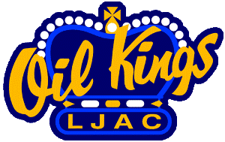

**Bantam AAA Head Coaching Position – 2019-20**

We are accepting applications for the position of Head Coach for the 2019-20 hockey season.

The Leduc Junior Athletic Club (LJAC) has a proud history & tradition of providing an excellent development program for elite level hockey players & coaches in the province of Alberta for the past thirty-five years.  The LJAC provides the leadership and coordination for the Bantam AAA, Minor Midget AAA & Midget AAA Hockey Alberta ADM/Elite Stream teams.  For the upcoming hockey season (2019/20) we have a coaching opportunity as the Head Coach of the Bantam AAA team.

The Leduc Woodbend Bantam AAA practices, trains, and plays out of the Leduc Recreation Centre.  The LJAC Bantam AAA team has a Draw Zone and plays in the competitive AMBHL.

Those interested should send a comprehensive resume and letter of application that would include:

* Hockey Coaching History
* Certification & Training –High Performance 1 is strongly recommended
* A minimum of three (3) coaching references
* **Deadline for applications is: Wednesday, May 1st**. Interviews will be set up after that date. Only those chosen for interviews will be notified.
* For more information please do not hesitate to contact:

Jim Jones

Vice President – Hockey Development

Leduc Junior Athletic Club

780-999-8230 (c)

[jjones@leduc.ca](mailto:jjones@leduc.ca)